Project 4:

AM Transceiver Design Using USRP

ECE 4271

Rahmaan Lodhia

Daniel Weiss

Santhosh Karnik

1. Transceiver and AM Overview
1.1. Overview of Program
The program’s purpose is to simulate the broadcast and receiving of an Amplitude Modulated (AM) signal through the NI USRP devices. Our program was split into two sections: the transmitter creating and broadcasting the AM signal and the receiver that obtained and played the found AM signal. The transmitter (AM_Tx.vi) creates a signal via microphone and then modulates and broadcasts the signal through the USRP. The receiver (AM_Rx.vi) receives a signal, demodulates the signal, and plays back the sound received.
1.2. Block Diagram of Program
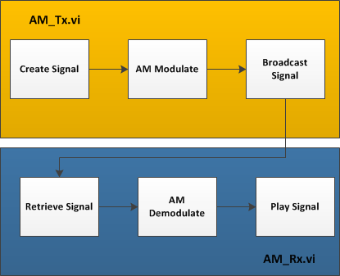
1.3 Background Theory
The program centers on the theory of amplitude modulation. The concept of amplitude modulation is as follows. A signal is multiplied by a carrier signal at a carrier frequency, which causes the signal to be mapped to a different frequency. Shown below is the resulting signal after the original signal m(t) is modulated.
This signal now has a new Fourier transform as shown below that demonstrates how the signal is copied to the carrier frequency w_{C}.
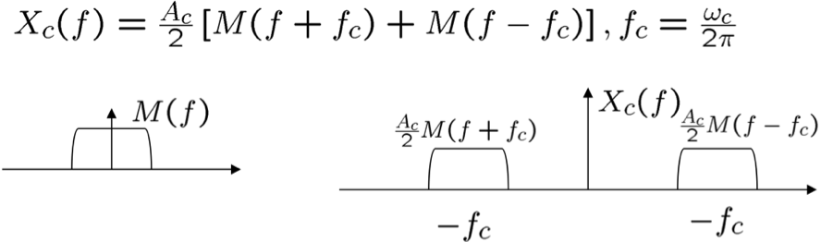
This resulting signal is then modulated again at the receiver side by the carrier signal that creates copies at double the carrier frequency and at the center. This resulting signal is then processed through a low-pass filter that will preserve the original signal, which has been duplicated due to the modulation factor.
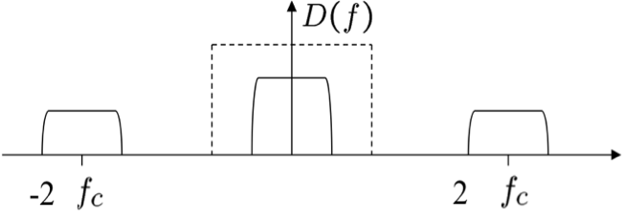

2. LabVIEW subVI Overview

2.1. AM_TX.vi
This VI sets up the USRP to transmit and sets up the computer microphone as an audio input. The program then captured 1 second of audio at 44.1k and then modulates the audio with AM continuously transmits the audio clip using the USRP radio. An IQ rate of 200k samples/second was used. A version of this code that captures continuous audio or wav files is described in the Troubleshooting section.

2.2. AM_RX.vi
The AM_RX subVI interfaces with the NI-USRP to receive a transmitted AM signal. The inputs to the AM_RX subVI are: the IQ sampling rate, the AM carrier frequency, the desired signal Gain, the low pass filter parameters, the desired frame duration, and the computer's sound card format. The AM_RX subVI loads one frame duration of the received IQ signal into a queue. Each frame is then decoded by converting the IQ signal into the sampled AM signal, demodulating the AM signal, and finally down sampling the AM signal to the rate of the sound card. This down sampled frame of the AM signal is then played on the computer that is connected to the receiver. This process is done continuously until the AM_RX subVI is stopped.

3. Troubleshooting
Initial testing of the Tx VI was performed with the audio captures in the main while loop and then immediately transmitted. The USRP would return a buffer under-run error and would cease transmitting after the first loop iteration. The microphone capture and the USPR transmit functions were then separated into two while loops. The first block either looped to capture the audio or read in a wav file. It thenwrote the audio data to a queue and relased the semaphore (only on the first iteration). The second loop (after the semaphore is released) checked the queue for new data and then either used that data or used the previous data for modulation and transmission.
The main difficulties encountered related to the use of the USRP as an analog transmitter/reciever. First, the USRP is unable to receive AM radio stations due to its native frequency range (50MHz to 2GHz). AM radio stations are in the range of 550kHz-1600kHz. The AM signal that we tranmitted and received contained mostly noise. This is due to the face that the audio is not protected in any way. Any distortion or reception problems will just be amplified by the reciever. If the audio were digital (quantized) then this distortion could likely be filtered out.
In order to remove the noise the team implemented a band pass filter on the received signal. After testing a number of parameters, the best pass band was determined to be ~300Hz-800Hz. This range filtered out the noise but it also filtered out the consonants from the spoken transmission.
Without additional work, the current AM Tx/Rx system is not feasible for audio transmision.

4 Future Work
While the AM_RX has limited success in receiving the transmitted signal, several improvements are still possible. The process for which the USRP modulates the AM signal to the carrier frequency is unknown. The algorithms used in the AM_TX and AM_RX subVIs could be better improved as a result of further study of the NI USRPs. Furthermore, the received signal has a very poor signal-to-noise ratio (SNR). Determining a method to increase the SNR of the received signal is critical to having a clear receieved signal.

Appendix A: Code Listing

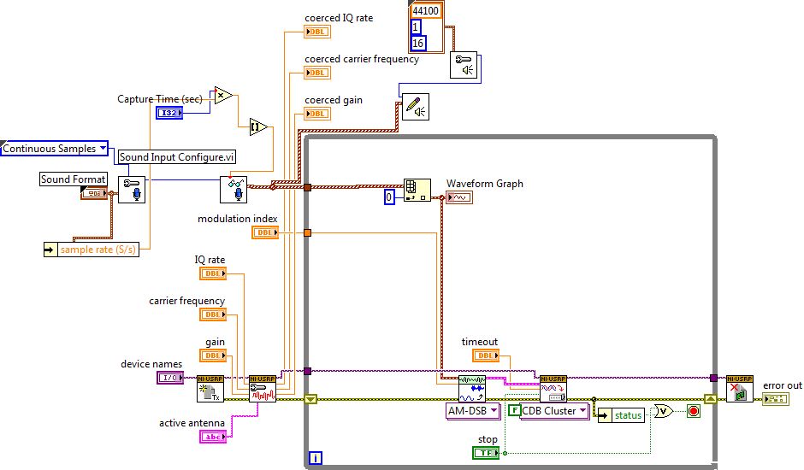
Figure 1. Simple AM transmitter that records 1 second of audio and transmits it.

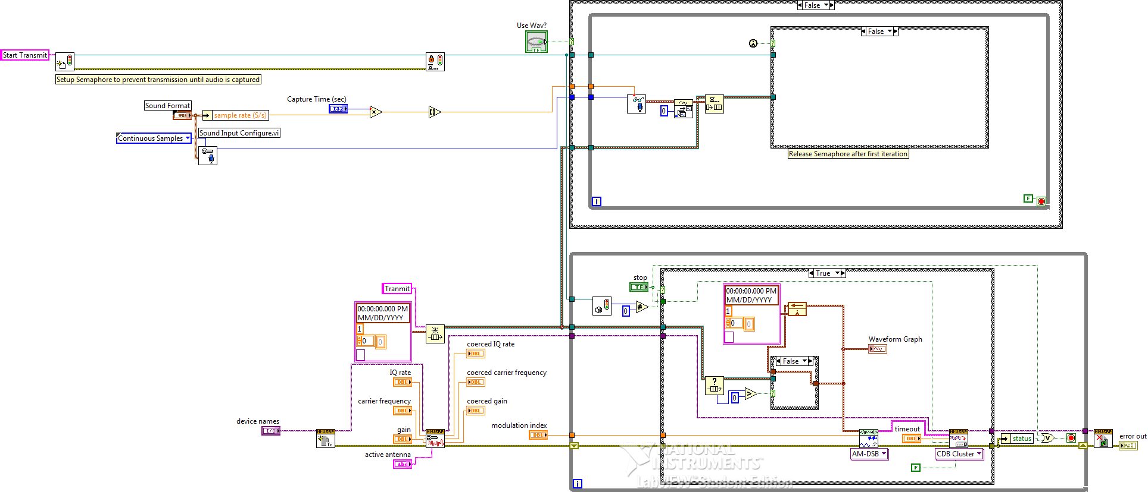
Figure 2. AM transmitter that either transmits a wav file or recorded audio in 1 second chunks.

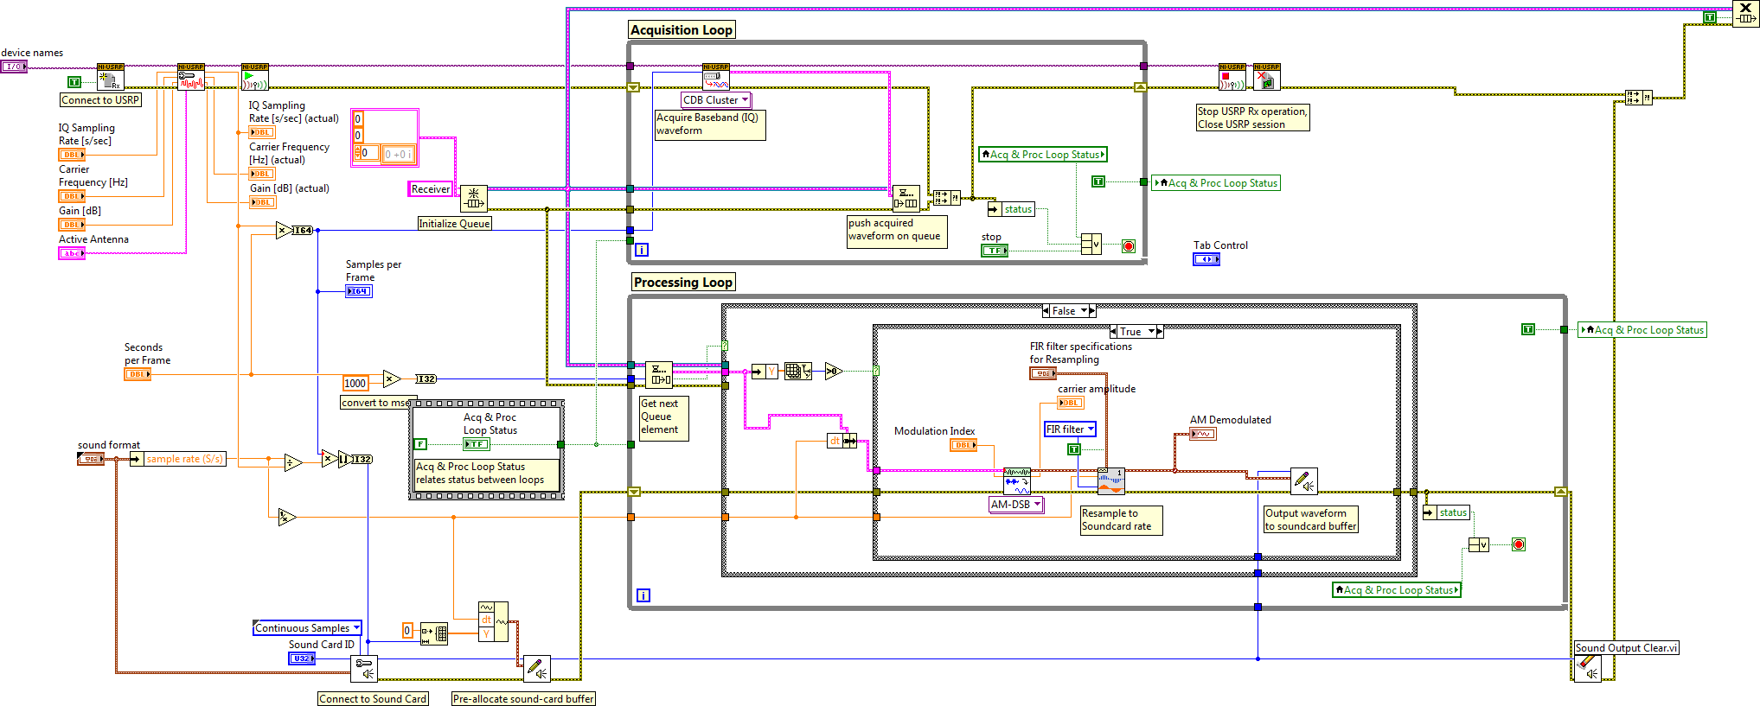
Figure 3. AM reciever.

